Anna Christine Sgro introduces ‘One Yanmar’ strategy for North America
Speaking at CONEXPO in Las Vegas, Yanmar CE’s North America President Anna Christine Sgro outlined how the One Yanmar strategy will give dealers access to one of the most complete and versatile CTL lineups globally – offering machines with both ASV Posi-Track technology and steel-embedded undercarriages.
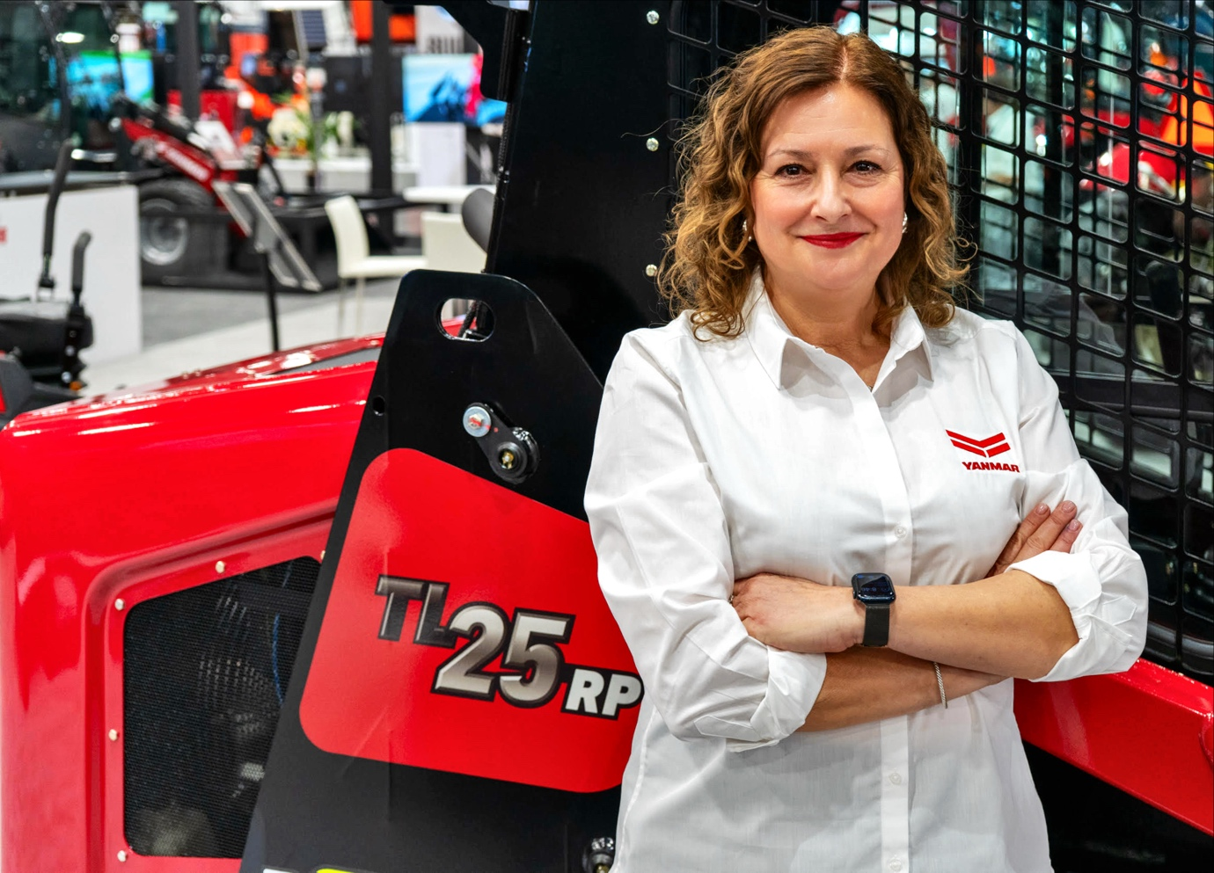
At the Yanmar Compact Equipment booth at CONEXPO in Las Vegas, Anna Christine Sgro addressed dealers, partners and industry observers with a clear message about the company’s direction in North America. At the center of that vision is One Yanmar, a strategy designed to unify the company’s compact equipment portfolio and sharpen its focus on long-term customer value.
As President of Yanmar Compact Equipment North America, Sgro has focused on advancing the company’s position through disciplined engineering and targeted investment, guided by a clear understanding of customer priorities.
The construction equipment market is rebounding, yet the conditions shaping the industry today differ from previous cycles. Customers are increasingly deliberate in how they invest, rental consolidation has shifted purchasing power, and margins remain under pressure across much of the sector. Against that backdrop, Sgro believes manufacturers must concentrate on the fundamentals that matter most to contractors and equipment owners.
A legacy shaped by engineering
Founded in Osaka, Japan in 1912, Yanmar has built its reputation on engineering milestones. In 1933 the company developed the world’s first practical small diesel engine, followed by innovations such as tracked carriers, rubber-tracked crawler excavators and zero tail swing technology. Today Yanmar holds strong positions across multiple equipment categories worldwide, including global leadership in mini excavators, with more than 30 percent market share in Japan.
For Sgro, that heritage continues to shape the company’s direction. “The discipline that built our leadership in excavators continues to guide how we approach every category,” she said during her CONEXPO remarks.
Listening to the people who run the machines
Since taking the helm of Yanmar Compact Equipment North America, Sgro has spent considerable time meeting dealers, key partners and equipment owners across the region. Those conversations consistently return to a common theme: contractors want machines they can rely on day after day with predictable operating costs. As Sgro summarised during her address in Las Vegas, “Reliability matters. Uptime matters. Predictable lifecycle cost matters.”
Construction companies operate in environments where downtime has immediate consequences. Equipment decisions therefore center on long-term performance and dependable ownership costs. “For us, reliability is not a feature. It is the foundation of our strategy,” Sgro explained.
The compact equipment industry remains cyclical, and manufacturers must build strategies that remain effective across changing market conditions. “The question is not how we chase the peaks,” Sgro told the audience. “The question is how we build a business that wins in every cycle.”
Expanding manufacturing capability in North America
A key element of that strategy lies in expanding Yanmar’s compact track loader capabilities. In 2019 the company acquired ASV, recognized for its patented Posi-Track® undercarriage technology designed to deliver traction and flotation in demanding terrain. The engineering and manufacturing facility in Grand Rapids, Minnesota serves as a hub for Yanmar’s compact track loader development in North America.
Yanmar has invested more than $32 million in the facility, with a further $30 million planned over the next five years to expand production capacity and engineering capability. The investment reflects Yanmar’s strategy of pairing global engineering expertise with strong regional manufacturing capability.
A unified compact equipment portfolio
The One Yanmar strategy brings together the ASV and Yanmar compact equipment portfolios under a unified Yanmar brand across North America. The move creates a cohesive lineup spanning mini excavators, compact track loaders, wheel loaders and tracked carriers.
Yanmar now provides two undercarriage systems within the same CTL portfolio. For Yanmar’s dealer network, this means access to one of the most complete and versatile CTL lineups globally, combining machines with ASV Posi-Track technology alongside models equipped with steel-embedded undercarriages. Contractors operating in mud, sand or snow can select ASV’s Posi-Track system, while construction applications involving harder surfaces can utilise steel-embedded track systems.
Pilot machines – including the TL25RP and TL50RP – were displayed at CONEXPO in Yanmar’s distinctive red livery, with a phased rollout planned beginning in 2026. “One Yanmar is not a slogan,” Sgro explained. “It brings clarity to our lineup and reinforces how we go to market as one unified compact equipment portfolio.”
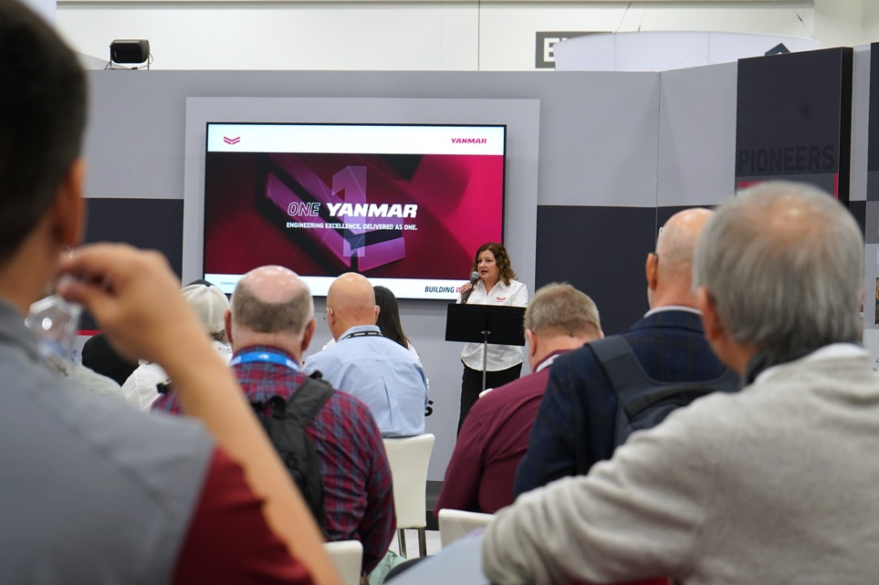
The growing role of connectivity
The strategy unveiled in Las Vegas also reflects broader changes in how equipment is managed throughout its lifecycle. At the show, Yanmar announced a partnership with telematics provider GeoForce aimed at strengthening the company’s connected equipment ecosystem.
More than 100,000 Yanmar machines worldwide already operate with telematics capabilities. The new cloud-based platform will expand fleet visibility and operational insights for equipment owners and dealers, supporting more informed decisions around maintenance and asset management. Connectivity is becoming an increasingly important part of equipment ownership, helping customers manage fleets more effectively over time.
A unified direction for the future
The initiatives announced at CONEXPO represent a deliberate evolution within Yanmar’s North American business. The strategy brings together global engineering heritage, expanded regional manufacturing capability, unified product portfolios and digital connectivity.
Through One Yanmar, Sgro believes the company is aligning engineering, manufacturing and market strategy around that principle.
“We are entering the next chapter of compact equipment in North America,” she said. “And One Yanmar is how we lead it.”
Ends.
March 2026

Valeria Iervolino Aishah Baz
Global Marketing & Communications PR support
Yanmar Compact Equipment Daredevil
valeria_iervolino@yanmar.com aishah.baz@daredevilpr.com
+39 380 58 20 485

About Yanmar Compact Equipment
Yanmar Compact Equipment (Yanmar CE) is a global leader in the design, manufacture and support of compact equipment for a range of segments, principally construction and other earthmoving applications. Its products include extensive ranges of mini and midi excavators, wheel loaders, wheeled excavators, compact track loaders and tracked carriers. These are supported by a wide range of services designed to ensure customer success. A global company with proud Japanese heritage, Yanmar CE has manufacturing facilities in Asia, Europe and North America – and an extensive international dealer network. Renowned for its innovative approach – it was the first to market with the now-benchmark mini-excavator, and is credited with popularizing the zero-tail swing concept – Yanmar CE remains a trusted brand known for its reliability, performance and commitment to customer satisfaction. These traits are demonstrated through the company’s tagline – ‘Building with you’.

For more details, please visit the official website. https://www.yanmar.com/global/construction/
About Yanmar
With beginnings in Osaka, Japan, in 1912, Yanmar was the first ever to succeed in making a compact diesel engine of a practical size in 1933. A pioneer in diesel engine technology, Yanmar is a global innovator in a wide range of industrial equipment, from small and large engines, agricultural machinery and facilities, construction equipment, energy systems, marine, to machine tools, and components. Yanmar’s global business operations span seven domains. On land, at sea, and in the city, Yanmar provides advanced solutions to the challenges customers face, towards realizing A Sustainable Future. For more information, please visit www.yanmar.com/global/about/.

