
News Release
June 17, 2026
Yanmar Holdings Co., Ltd.

Yanmar Showcases Technologies for the Future of Construction at CSPI-EXPO 2026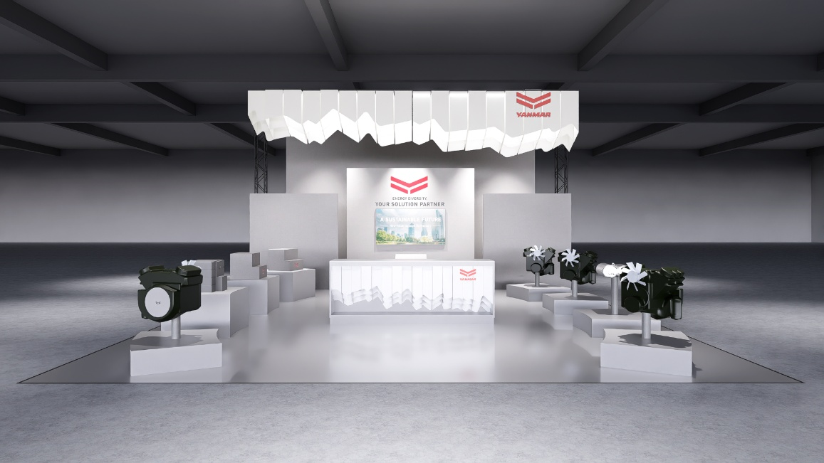
Image of the Yanmar Power Technology booth.

Osaka, Japan (June 17, 2026) – Yanmar Holdings Co., Ltd. will showcase a broad range of technologies supporting the future of construction at the 8th Construction & Survey Productivity Improvement Expo (CSPI-EXPO 2026), held at Makuhari Messe in Chiba Prefecture, Japan, from June 17 to June 20, 2026.

Through exhibits from Yanmar Power Technology Co., Ltd. (YPT) and Yanmar Compact Equipment (Yanmar CE), visitors will experience how advances in power solutions, electrification, automation, and digital technologies can help improve sustainability, productivity, and jobsite performance. Together, the exhibits demonstrate Yanmar's commitment to creating practical solutions that support both decarbonization and more efficient construction operations.

Advancing Sustainable Power Solutions
Under the theme "ENERGY DIVERSITY, YOUR SOLUTION PARTNER," YPT will showcase technologies designed to support a lower-emission future while meeting the performance requirements of industrial applications. Highlights include a concept model of an industrial hydrogen engine and the company's new Compact ATD (After Treatment Device), which will be displayed publicly for the first time.

The industrial hydrogen engine is based on Yanmar's latest 4TN101 diesel engine platform and is designed to operate on hydrogen fuel without requiring significant changes to the existing engine architecture. By leveraging proven engine technology, the concept demonstrates a practical pathway toward decarbonization.

YPT will also introduce its new Compact ATD, an exhaust aftertreatment device that reduces particulate matter (PM) and nitrogen oxide (NOx) emissions. Compared with conventional systems, the Compact ATD offers a smaller installation footprint, enabling greater flexibility for customers across a wider range of applications.
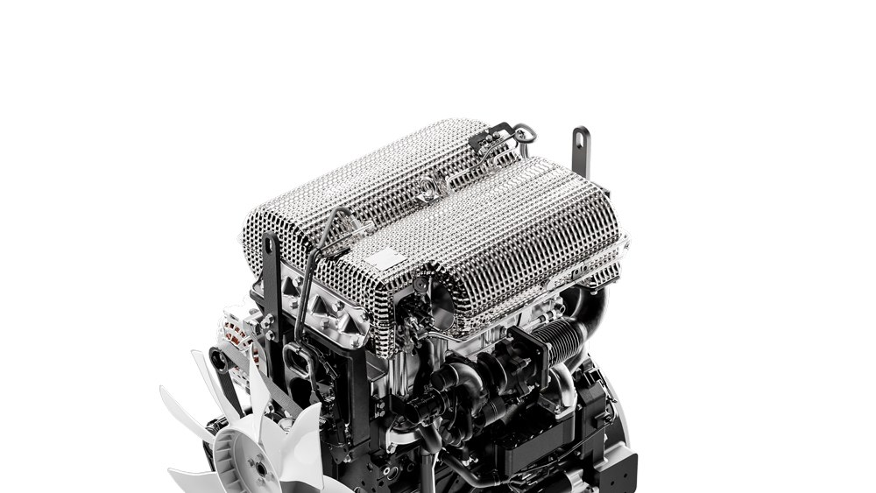
The Yanmar compact ATD exhaust aftertreatment device.

In addition, YPT will exhibit the 4TN88B LPG/Gasoline Bi-Fuel engine, a clean gas engine developed for industrial machinery applications. The engine combines low fuel consumption, compact design, and high reliability while supporting reduced CO₂ emissions and stable long-duration operation.

Together, these technologies reflect Yanmar's multi-pathway approach to helping customers reduce emissions while maintaining the reliability and performance demanded by modern construction and industrial equipment.
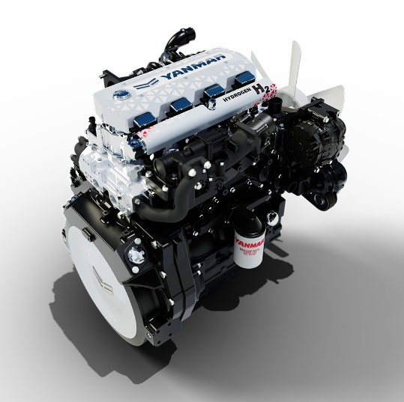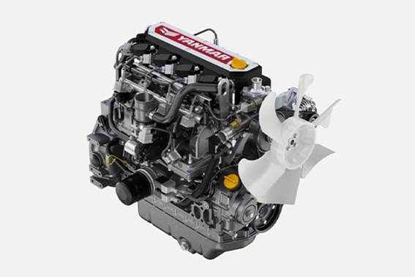
Left: Yanmar industrial hydrogen engine is based the 4TN101; right: the 4TN88B LPG/Gasoline Bi-Fuel engine.

Enhancing Productivity Through Electrification and Digital Construction Technologies
Yanmar CE will showcase technologies aimed at improving productivity, precision, safety, and operator experience on construction sites. Exhibits include the ViO30-7 equipped with blade 3D machine control technology, demonstrating how advanced machine control systems can improve construction accuracy and operational efficiency.

The company will also present electric equipment including the SV08e electric mini excavator and C12Re electric carrier, highlighting solutions that support both reduced environmental impact and improved jobsite productivity. Visitors will also be able to experience machines equipped with tiltrotator technology, remote-control functionality, and Yanmar's Active Tip-over Mitigation System (ATMS), which helps reduce rollover risk during operation.

Through these exhibits, Yanmar CE will demonstrate how electrification, automation, and digital construction technologies are helping shape the next generation of construction sites.
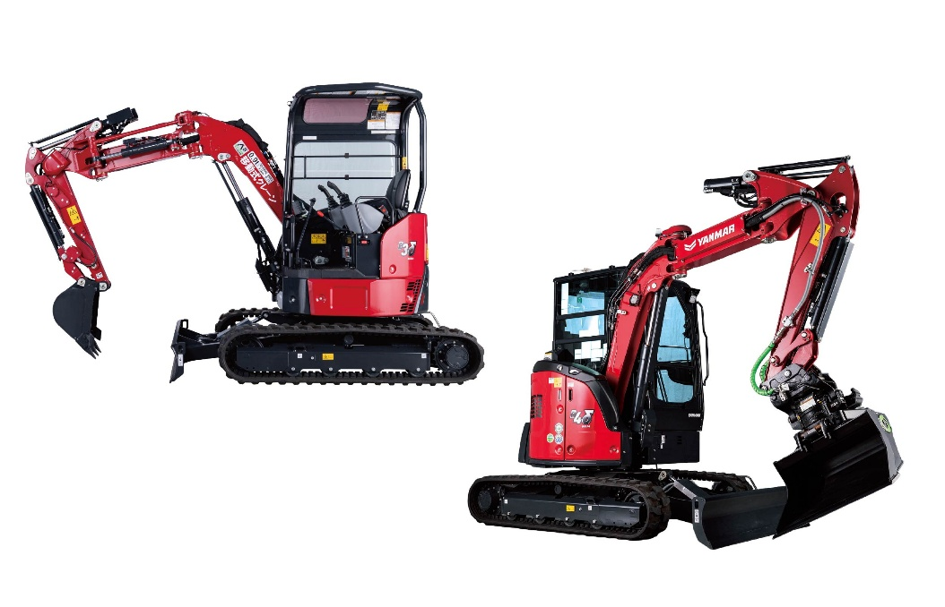
Left: Yanmar Delta series equipped with 2D machine control; right: Delta series equipped with a tiltrotator.

Special Appearance by Anton Wörmann
On June 18, Yanmar CE Global Brand Ambassador Anton Wörmann will visit the Yanmar CE booth to discuss Sweden's DIY culture and share insights from his renovation projects involving traditional homes and vacant properties. His presentation will explore the role of construction equipment and craftsmanship in creating living spaces and strengthening communities.



About Yanmar
With beginnings in Osaka, Japan, in 1912, Yanmar was the first ever to succeed in making a compact diesel engine of a practical size in 1933. A pioneer in diesel engine technology, Yanmar is a global innovator in a wide range of industrial equipment, from small and large engines, agricultural machinery and facilities, construction equipment, energy systems, marine, to machine tools and components — Yanmar’s global business operations span seven domains. Guided by its Brand Statement, “A Sustainable Future – New Value Through Technology,” Yanmar provides advanced solutions to the challenges customers face on land, at sea, and in the city, working towards realizing a sustainable future.
https://www.yanmar.com/global/about/

Note: Information contained in the news release is valid at the time of publication and may differ from the most recently available information.

Inquiries
Corporate Communications Division, Yanmar
newsroom@yanmar.com

